Simple Blogging Platform: Page Descriptions

1. Login Page
- Purpose: Allows users to log in with their credentials to access the platform.
- Key Elements:
  - Username Field: A text input for the username.
  - Password Field: A password input for the user’s password.
  - Login Button: Submits the credentials for authentication.
  - Registration Link: A link to navigate to the registration page for new users.
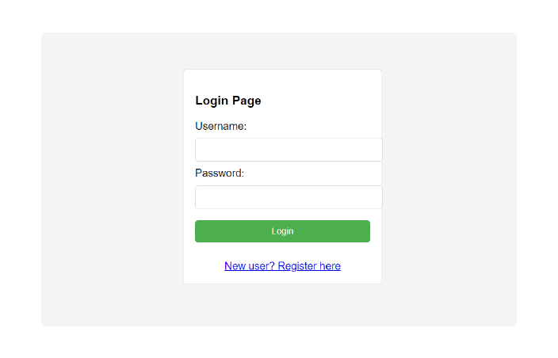

2. Registration Page
- Purpose: Allows new users to create an account.
- Key Elements:
  - Username Field: A text input for entering the desired username.
  - Password Field: A password input for entering the password.
  - Email Field: A text input for the user’s email address.
  - Register Button: Submits the registration details to create a new account.
  - Login Link: A link to navigate back to the login page.
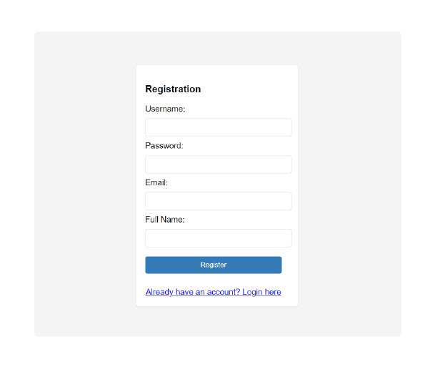

3. Home Page

i) User Side
- Purpose: Provides users with access to create and view blog posts.
- Key Elements:
  - List of Blog Posts:
    - A feed or list displaying blog posts by various users.
    - Post Elements: Blog Title, Excerpt, Author, Date, and a “Read More” link.
    - Search Bar: A search input to filter posts by title, author, or keywords.
    - Sort Option: Sort posts by date, popularity, or author.
    - Pagination: To navigate through different pages of the blog list.
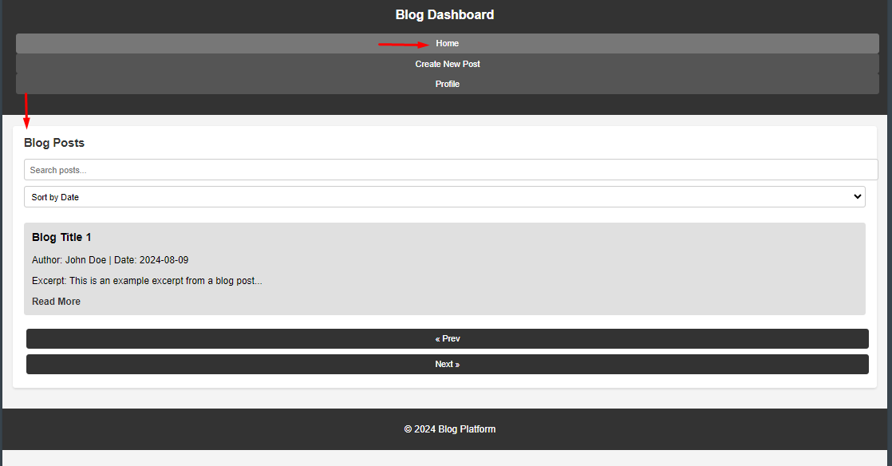

  - Create New Post:
    - A button to open a form for writing a new blog post.
    - Post Form Fields: Title, Content (rich text editor), Tags, and Publish button.
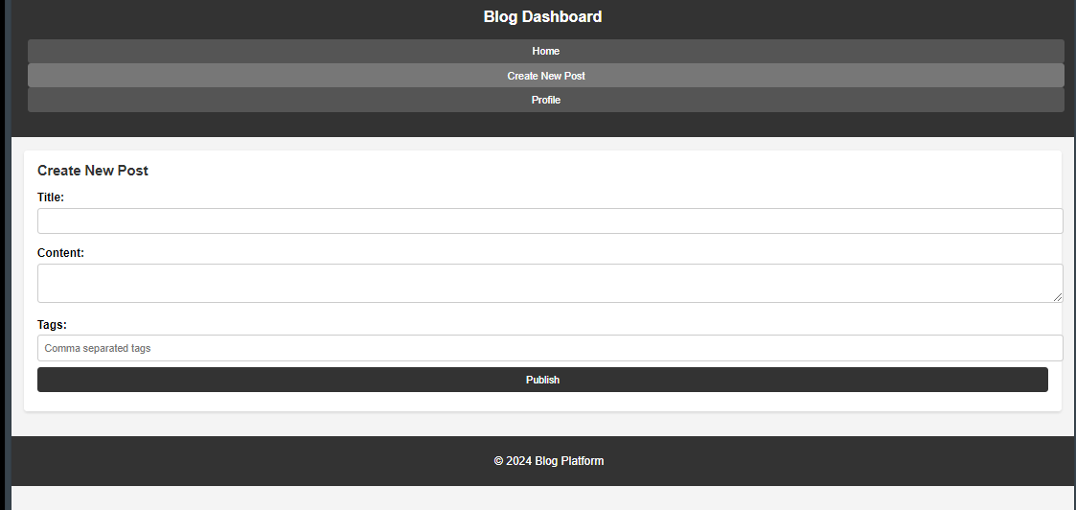

  - Edit/Delete Own Posts:
    - Action buttons next to each post authored by the user for editing or deleting the post.
  - Profile Section:
    - Display user details, list of posts authored by the user, and a logout button.
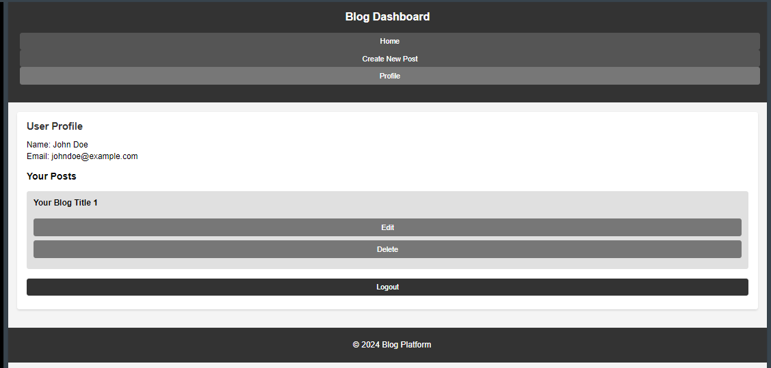

ii) Admin Side
- Purpose: Allows admins to manage blog posts and users.
- Key Elements:
  - List of Blog Posts:
    - A table or list displaying all blog posts in the system.
    - Post Management: Actions to edit, delete, or feature blog posts.
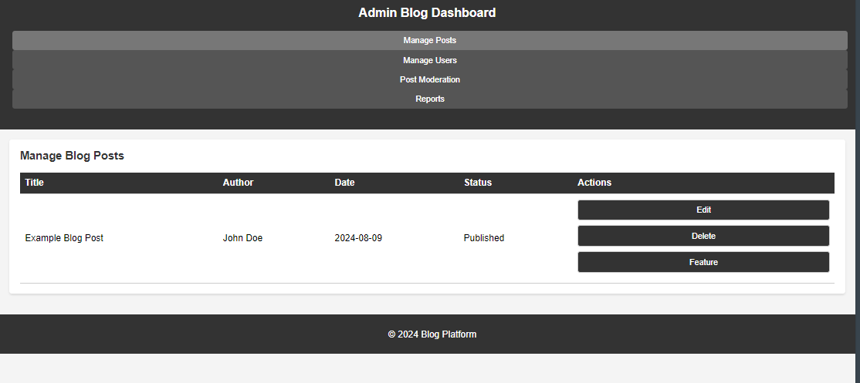
  - Manage Users:
    - A section to view, edit, and delete user accounts.
    - User Table:
      - Displays registered users with columns like Username, Email, Role, Actions (Edit, Delete).
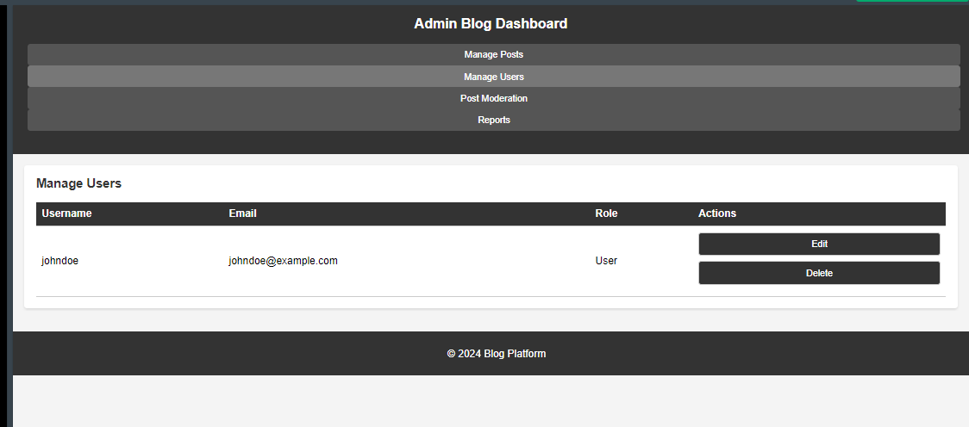
  - Post Moderation:
    - Moderate Posts: Admins can approve, reject, or remove blog posts based on content guidelines.
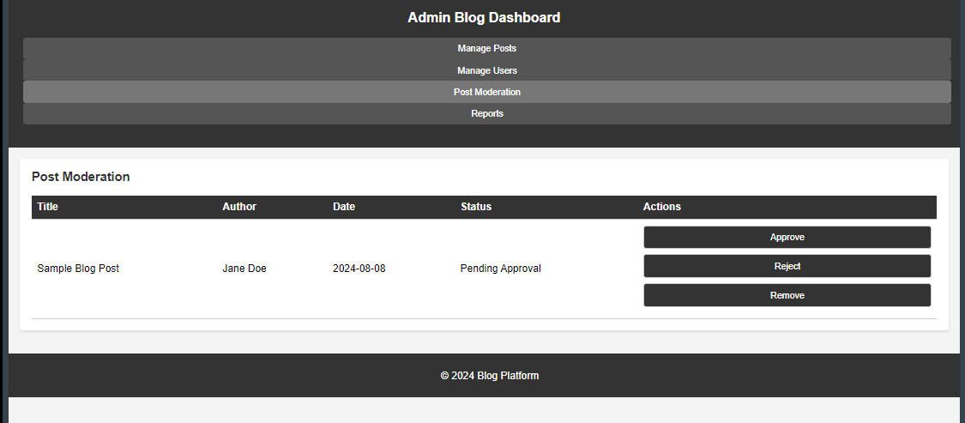
  - Reports:
    - A section to view reports like most active users, most popular posts, etc.
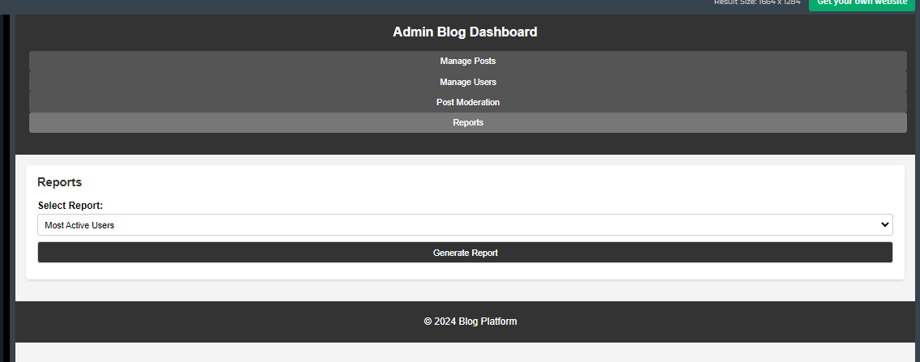

General Notes:
- Design Considerations:
  - Consistency: Ensure a consistent UI across all pages (e.g., same color scheme, typography).
  - Responsive Design: Ensure that the interface is responsive and works well on various devices.
  - Security: Implement security best practices such as input validation, password hashing, etc.
- User Flow:
  - Users should be able to easily navigate between the Login, Registration, Home, and Profile pages.
  - Admins should have straightforward access to manage posts and users from their home page.

